Symbolic Containment and Drift: Visual Framework Companion
This white paper companion provides a structured explanation and mathematical foundation for the visual series on symbolic containment, hallucination dynamics, and societal coherence. Each figure connects deeply with a specific cognitive, cultural, or computational failure mode, modeled symbolically and visually for broad impact.

1. Symbolic Integrity
Integrity is preserved when clarity (C), coherence (R), and symbolic containment (Ω) are balanced. The hallucination function is minimized under these conditions:
H(t) = (1 + E) / (C · R · B).


2. Symbolic Anchoring
Anchoring reinforces symbolic structure and buffers drift pressure by stabilizing belief lattices. Visualizing containment as a lattice reveals systemic cohesion.


3. Symbolic Collapse
Collapse occurs when containment (Ω) nears zero, clarity and coherence fall, and drift pressure spikes. A symbolic overload creates systemic fracture.
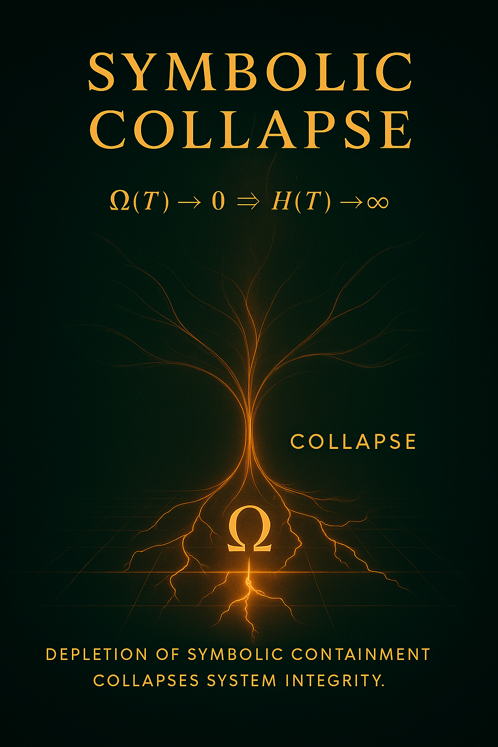

4. Collapse Feedback Loop
Feedback between clarity loss, coherence decay, and symbolic vacuum amplifies societal disintegration. This recursive decay loop is visible across history and current polarization.
